De Heus Construction B.V.

10mT cable laying tensioner technical specification

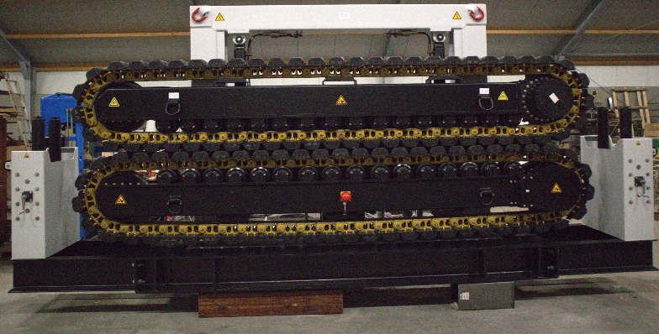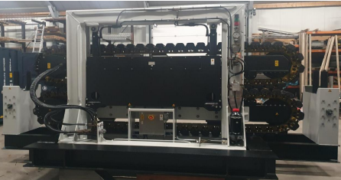

Description; The tensioner system consist into three basic packages:
1 - Tensioner, 2 - Electrical / Hydraulic Power Unit (EPU in 10 ft container), 3 - Remote Control Unit (RCU)
Tensioner The robust Caterpillar Tensioner consists of two vertically orientated caterpillar type track carriages with rubber composite "V" shaped pads between which the Product is gripped.
There is one moving carriage and one fixed carriage, the moving carriage slides on two vertical steel shafts and is moved by grip cylinders. The Tensioner is designed to impart linear motion to a product; the product can be cable, flexible flow lines, rigid pipe, wire rope etc. Linear motion is achieved by driving both track units at one end, producing tractive pull force into the product through friction between the track pads and the product outer surface. The Tensioner is controlled from the remote control unit (RCU), the grip function can be controlled automatically, from the RCU, or by local control manually, at the tensioner

1 - Tensioner specifications:

- Electrical driven cable tensioner with Siemens weintek control system and integrated hydraulic power unit.
- Outboard from gearbox end Track Contact Length 3.250 m
- Nominal load: 100kN
- Static brake load: 125kN (min. holding capacity)
- Clamping force: 25T
- Maximum Designed Speed: 960 m/hour
- Minimum Designed Speed: 120m/hour
- Track Opening: 400 mm
- Maximum cable diameter: 400 mm
- Minimum cable diameter: 80 mm
- Electrical drive: 2 x 22.5kW/50Hz
- Electrical power supply 400VAC@50Hz/460VAC@60Hz
- Transmission: Planetary gearbox
- Dimensions 6000 x 1750 x 3250 mm
- Weight 12.500 kg
- Basic material: Carbon steel with lifting eyes
- Conservation, 2-layer offshore coating

2 – Electrical/Hydraulic power unit

The basic power pack electrical controls are mounted on the electrical control cabinet, and are simple start stop push button controls with indicator lamps along with a mains isolator. The PLC control electronics are housed in a box mounted on the Tensioner, and within the RCU; there are 2 multi-core control cables, which connect the RCU and the Tensioner. When electrical power is present, and after the E Stop reset button has been pressed, the HPU motor can be Started/Stopped, at either the HPU, or from the RCU. The power pack main engine is used to control direction, speed and tension; it also provides a pressure and flow source for operating the Tensioner brakes. The RCU must always be plugged into the tensioner so as to have continuity in the E-STOP circuit. This applies to the Tensioner control cable as well. The Auxiliary Grip pump supplies a fixed flow to the grip circuit, there is a pressure relief valve and filter fitted on the HPU but all the grip control valves are contained in a manifold on the Tensioner. HPU Controls Cabinet Panel HPU Hydraulic Connections HPU Electric Motor

Control Cabinet / electrical components:

- 2 x E-motors
- 2 x E-stops
- Sensors (pressure transmitters, switches, encoders, load cells)
- Solenoids of hydraulic valves
- 2 x Frequency drives
- PLC Siemens weintek modules/control system
- Power distribution tensioner & hpu
- Start/stop relays for hpu

Tensioner is equipped with the below control modes:
- Pay in/out speed 960 m/h @ 50Hz
- Pull force limitation (10kN..100kN)
- Adjustable clamp force (10kN..250kN)

Tensioner is equipped with following secondary functions:
- Open/close tracks (opening width ± 400mm)
- Load measurement
- Integrated line speed measurement
- Mechanical manually adjustable front/end guiding rollers
- Standard modes: Speed control pay in/out
- Electric driven and controlled speed control

The HPU skid houses the electrical control cabinet and hydraulic power system. The HPU pump has a closed loop system for the grip function. There is also an oil cooling system (heat exchanger) fitted. The basic power pack electrical controls are mounted on the electrical control cabinet, and are simple start/stop button controls with indicator lamps along with a mains isolator. The PLC is also in this cabinet. The PLC control are housed in the RCU. When electrical power is present, and after reset the E. stop circuit, the HPU motor can be started/stopped, at either the HPU or from the RCU. The RCU must be always plugged into the tensioner so as to have continuity in the E stop circuit. This apply to the tensioner control cable as well.
The pump supplies a fixed flow to the grip circuit, there is a pressure relief valve and filter fitted on the HPU, but all the grip control valves are contained in a manifold on the tensioner.

3 - RCU (Remote Control Unit)
Remote control of the tensioner is electrically operated from the remote control unit (RCU) . the RCU is used as the normal method of controlling the tensioner.
This RCU provides the remote operator interface to the following HPU and tensioner control functions.
There is a 3 position switch for selection of direction ,potentiometer for speed and tension control. The tensioner brakes are lifted automatically when the direction switch is selected either ”pay- in or Pay-out”, and the potentiometer is moved from the zero position.
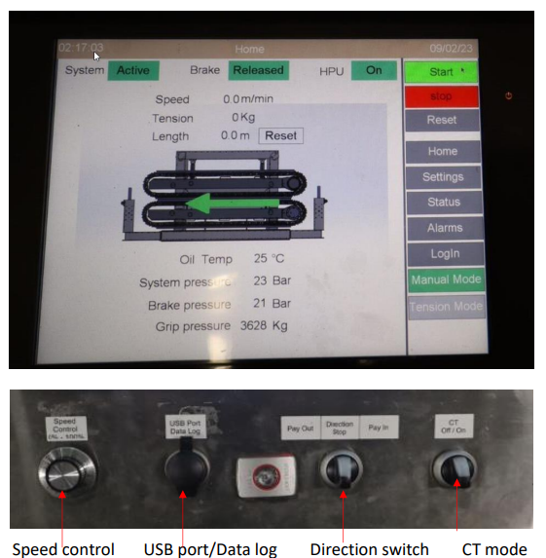

Emergency remote is stored on the side of the electrical main cabinet. It is designed to create a safe situation in case

there is an electronic failure on the PLC control system.

Buttons on remote:

On left and right side 2 black push buttons. Push it simultaneously to operate.

Direction switch. Pay in – pay – out.

Potentiometer to control the speed.

E. stop button.

10 meter of control cable are connected to remote.

General Tensioner inclusions:
- Factory Acceptance Test at our premises comprising
- Control system factory test
- Checking connections
- Basic movement tests of equipment
- Overall inspection of equipment
- Documentation: Manuals (Operation, maintenance)
- General Arrangement drawing with lifting plan
- Electrical diagrams
- Functional description of the software
- Components documentation
- Drawings in PDF format
- Critical Spare Parts List added
- Factory Acceptance Test report
Constant tension mode
- Follow/hold back mode by measuring pull force. load limitation Speed pay in out with adjustable load limiting force, controlled by the software with a setting from external control, mechanical brake release automatically. Feedback for force and speed by means of loadcell and position measurement at the tensioner.

Exclusions:
- Certification by any Class authority
- Electrical cabling and installation on board (in between tensioner and control cabinet)
- Materials and labor for the installations on board
- Commissioning of the system onsite
- Power cabling from Site/vessel/barge to equipment
- Rigging
- Spare parts
- Data logging system
- Training, - Transport, travelling and lodging
- Excluding all activities and / or materials not described in this order
- By request we can quote for or execute above mentioned exclusions
- No rights can be taken to the written specifications or illustrations. Details, could change in accordance to technical complications at the basic design.

In all cases in which we act as a provider or supplier on our quotations,
on orders given to us and on with us concluded agreements the METAALUNIE TERMS AND CONDITIONS of application. We reject your purchase terms and conditions.

De Heus Construction B.V.. Heuvelsesteeg 5, 3959 BA Overberg,
Bank; NL53 RABO 0363657533 Kamer van Koophandel: 81257783 BTW nr; NL862022

